

**Thank you to our sponsors! With their help we were able to put on this colloquium:**

**Platinum Sponsors:**





**Bronze Sponsors:**



** **





**Message from the organizers**

On behalf of the organizing team, we are delighted and privileged to welcome you to the 22nd Environmental Chemistry Colloquium (ECCXXII) at the University of Toronto. This year’s ECC will be held *in person* at the Evergreen Brick Works on May 8th and at the University of Toronto (St. George campus) on May 10th. In light of the uncertainties over the past few years during the global pandemic we are excited to come together in person once again. We would gladly like to welcome Brent and Nick for our career panel on May 8th to nurture new networks within our Environmental Chemistry Community.

We encourage everyone to take this time to interact with your peers and faculty. We strive to offer everyone an exciting and rewarding program, and we hope that you will have an enjoyable ECCXXII!

Andrew, Carolyn, and Isla

May 2023

**Student organizers**:

**Andrew Folkerson** (andrew.folkerson@mail.utoronto.ca)

**Carolyn Liu-Kang** (carolyn.liukang@mail.utoronto.ca)

**Isla Wrightson** (isla.wrightson@mail.utoronto.ca)

**Faculty advisor**:

Prof. Hui Peng (hui.peng@utoronto.ca)

**Special thanks:**

Career panel:

Brent Pautler (SiREM)

Nick Key (JFR Science)

Social media ambassadors (@EnviroChemUofT on twitter):

Kristen Yeh

Isla Wrightson

Program cover design

Kristen Yeh

*Special thanks to previous organizers, Zilin Zhou and Sivani Baskaran, for their ECC SOP. Thanks to Lisa Ngo and Jeannie Pak at the business office for managing our funds.*

|  |  |
| --- | --- |
| **Monday, May 8th**  ***See p. 9-28 for abstracts for the following presentations*** | |
| 9:00 | *Opening remarks* |
| **Session 1** Jenny Oh and Jillian Downey, Chairs | |
| 9:15 | **Chemoproteomics identification of human liver fatty acid binding protein as a protein target of triphenyl phosphate**  *Jolie Miller and Hui Peng* |
| 9:30 | **Development of a simplified oxygenated system for *in vivo* solution state NMR**  *Peter Costa and Andre Simpson* |
| 9:45 | **Soil organic matter biogeochemical trajectories are altered uniquely with 66 years of litter manipulation in forests**  *Isla Wrightson and Myrna Simpson* |
| 10:00 | **Aqueous nitration of phenols with dissolved nitrite: a formation mechanism of atmospheric brown carbon**  *Yutong (Maggie) Wang and Jonathon Abbatt* |
| 10:15 | **An analysis of nitrate reactivity with volatile organic compounds across Canada**  *Brendan O’Connell and Jennifer Murphy* |
| 10:30 | *Break (15 min)* |
| **Session 2** Brendan O’Connell andChris Rusiewicz, Chairs | |
| 10:45 | **2D 1H-13C experiments for targeted analysis of structural sub-classes *in-vivo***  *William Wolff and Andre Simpson* |
| 11:00 | **Evaluating land-atmosphere fluxes of nitrogen species in the Canadian Earth System Model**  *Gavin McCurdy and Jennifer Murphy* |
| 11:15 | **The influence of polar bears’ catabolic state and dietary composition on the potential biomagnification of PCBs**  *Yuhao Chen and Frank Wania* |
| 11:30 | **Exploring proton-only NMR experiments and filters for Daphnia i*n vivo*: potential and limitations**  *Kiera Ronda and Andre Simpson* |
| 11:45 | **Impacts of SVOCs and relative humidity on the deposition rate of ozone to permeable indoor surfaces**  *Jillian Downey and Jonathan Abbatt* |

|  |  |  |
| --- | --- | --- |
| **12-1:30**  **Networking and Lunch** | | |
| **Session 3** Brad Isenor and Jolie Miller, Chairs | |
| 1:30 | **Exploring the potential of broadband complementary metal oxide semiconductor micro-coil nuclear magnetic resonance for environmental research**  *Daniel Lysak and Andre Simpson* |
| 1:45 | **Investigating the impacts of warming and nitrogen-addition on soil-derived dissolved organic matter**  *Atzín San Román and Myrna Simpson* |
| 2:00 | **Atmospheric reaction in single levitated droplets under variable humidities**  *Chris Rusiewicz and Jamie Donaldson* |
| 2:15 | **DREAMTIME NMR of slow spinning systems using High-Resolution-Magic Angle Spinning**  *Rajshree Ghosh Biswas and Andre Simpson* |
| 2:30 | **Photoreaction aging of biomass burning brown carbon**  *Carolyn Liu-Kang and Jonathan Abbatt* |
| 2:45 | *Break (15 min)* |
| **Session 4** Gavin McCurdy and William Fahy, Chairs | |
| 3:00 | **Evaluation of irradiated Wyoming-type bentonite natural organic matter at varying moisture levels**  *James Neurauter and Myrna Simpson* |
| 3:15 | **Integrated screening of bioactive contaminants contributing to the high receptor activities in St. Lawrence beluga whales**  *Holly Barrett and Hui Peng* |
| 3:30 | **NMR in an eggshell – *in vivo* carbon tracing and embryogenesis study of Society Finches**  *Katrina Steiner and Andre Simpson* |
| 3:45 | Haloacetonitrile toxicities attributed to distinct reactions with proteins thiols  *Kirsten Yeungand Hui Peng* |
| 4:00 | **Observing secondary organic aerosol formation from oxidation of cannabis smoke**  *Kristen Yeh and Jonathan Abbatt* |
| **End of ECC XXII Day 1**  *Feel free to walk around and enjoy Evergreen Brick Works!* | |

|  |  |
| --- | --- |
| **Wednesday, May 10th**  ***See p. 29-38 for abstracts for the following presentations*** | |
| 9:00 | *Opening remarks* |
| **Session 5** Katrina Steiner and Victor Li, Chairs | |
| 9:15 | **Fate of the azole fungicide fluconazole in sunlit waters: kinetics, transformation products, and reaction mechanisms**  *William Fahy, Jonathan Abbatt, and Scott Mabury* |
| 9:30 | **Avoiding regrettable replacements: can the introduction of novel functional groups move PFAS from recalcitrant to reactive?**  *Andrew Folkerson and Scott Mabury* |
| 9:45 | **Nitrous oxide profiles from the Canadian Atmospheric Laser Absorption Spectrometer Experiment Test-bed**  *Mark Panas and Jennifer Murphy* |
| 10:00 | **Characterizing the oxidative potential associated with biomass burning aerosol from Canada**  *Bradley Isenor and Arthur Chan* |
| 10:15 | **Field observations of size-resolved particulate alkyl amines in urban Toronto during winter 2022-23**  *Xiaoying Yang and Jennifer Murphy* |
| 10:30 | *Break (15 min)* |
| **Session 6** Atzín San Román andWilliam Wolff, Chairs | |
| 10:45 | **Evaluation of adsorption isotherm models for determining the partitioning of ammonia between soil and soil-pore water in environmental samples and potential ammonia emissions sourced from Toronto’s urban greenspace**  *Matthew Davis and Jennifer Murphy* |
| 11:00 | **Oxidation of bisphenol A via gas-surface ozonolysis: chemical transformation of a widespread organic pollutant**  *Jie Yu and Jonathan Abbatt* |
| 11:15 | **The roles of temperature and pH in the gas-particle partitioning of ionizable organics in the atmosphere**  *Olivia Driessen and Jennifer Murphy* |
| 11:30 | **Identifying and quantifying atmospheric sources of organic contaminants to the habitat of the St. Lawrence Estuary Belugas**  *Jenny Oh and Frank Wania* |
| 11:45 | **Benchmarking a portable sensor for early warning monitoring of water quality**  *Zhuoyuan (Victor) Li and Hui Peng* |
| **12:30-2:30**  **LUNCH**  *Faculty BBQ!* | |
| **End of ECC XXII Day 2**  ***Please see p. 7-8 for the committee meeting schedule*** | |

|  |  |  |  |  |  |  |  |  |  |  |
| --- | --- | --- | --- | --- | --- | --- | --- | --- | --- | --- |
| **Thursday, May 11th**  ***Committee meeting schedule part 1***  *All UTSG committee meetings with be in person (unless noted otherwise)* | | | | | | | | | | |
| **Time** | | **Student** | **Member 1/PI** | | **Member 2** | | **Member 3** | | **Location** | |
| **9:00** | | Yutong (Maggie) Wang | Jon Abbatt | | Jen Murphy | | Arthur Chan | | **In person (LM319)** | |
| **9:20** | | Xiaoying Yang | Jen Murphy | | Jon Abbatt | | Arthur Chan | |
| **9:40** | | Brendan O’Connell | Jen Murphy | | Jon Abbatt | | Arthur Chan | |
| **10:00** | | Jie Yu | Jon Abbatt | | Arthur Chan | | Jamie Donaldson | |
| **10:20** | | Brad Isenor | Arthur Chan | | Jon Abbatt | | Hui Peng | |
| **10:40** | | *Break (10 min)* | | | | | | | | |
| **10:50** | | Matthew Davis | Jen Murphy | | Jon Abbatt | | Jamie Donaldson | | **In person (LM319)** | |
| **11:10** | | Chris Rusiewicz | Jamie Donaldson | | Jon Abbatt | | Hui Peng | |
| **11:30** | | Olivia Driessen | Jen Murphy | | Jon Abbatt | | Hui Peng | |
| **11:50** | | Jillian Downey | Jon Abbatt | | Hui Peng | | Jen Murphy | |
| **12:10** | | Zhuoyuan (Victor) Li | Hui Peng | | Vianey Leos Barajas | | Jen Murphy | |
| **12:30** | | *Lunch (30 min)* | | | | | | | | |
| **1:00** | | Yuhao Chen | Frank Wania | | Hui Peng | | Derek Muir | | **Zoom** | |
| **1:20** | | Jenny Oh | Frank Wania | | Hui Peng | | Derek Muir | |
| **1:40** | | Holly Barrett | Hui Peng | | Frank Wania | | Ruby Sullan | | **In person (LM319; Ruby on Zoom)** | |
| **2:00** | | Kristen Yeh | Jon Abbatt | | Arthur Chan | | Frank Wania | | **In person (LM319)** | |
| **2:20** | | Carolyn Liu-Kang | Jon Abbatt | | Jen Murphy | | Frank Wania | |
| **Thursday, May 11th**  ***Committee meeting schedule part 2***  *All UTSC committee meetings with be on zoom* | | | | | | | | | | |
| **Time** | **Student** | | | **Member 1/PI** | | **Member 2** | | **Member 3** | | **Location** |
| **9:40** | Rajshree Ghosh Biswas | | | Andre Simpson | | Myrna Simpson | | Kagan Kerman | | Zoom |
| **10:00** | Jolie Miller | | | Hui Peng | | Myrna Simpson | | Mariam Diamond | |
| **10:20** | Atzín San Román | | | Myrna Simpson | | Jen Murphy | | Andre Simpson | |
| **10:40** | *Break (10 min)* | | | | | | | | | |
| **10:50** | William Wolff | | | Andre Simpson | | Myrna Simpson | | Xiao Zhang | | Zoom |
| **11:10** | Kiera Ronda | | | Andre Simpson | | Myrna Simpson | | Ruby Sullan | |
| **11:30** | Katrina Steiner | | | Andre Simpson | | Myrna Simpson | | Ruby Sullan | |
| **11:50** | Peter Costa | | | Andre Simpson | | Myrna Simpson | | Ruby Sullan | |
| **12:10** | Daniel Lysak | | | Andre Simpson | | Myrna Simpson | | Ruby Sullan | |
| **12:30** | *Lunch (30 min)* | | | | | | | | | |
| **1:00** | Isla Wrightson | | | Myrna Simpson | | Andre Simpson | | Jon Abbatt | | Zoom |
| **1:20** | James Neurauter | | | Myrna Simpson | | Jon Abbatt | | Andre Simpson | |
| **1:40** | Gavin McCurdy | | | Jen Murphy | | Jon Abbatt | | Myrna Simpson | |

|  |  |  |
| --- | --- | --- |
| **Professor** | **In person (LM319)** | **Zoom (link to be sent)** |
| Jon Abbatt | 9:00-10:40  10:50-12:10  2:00-2:40 | 1:00-2:00 |
| Arthur Chan | 9:00-10:40 |  |
| Jamie Donaldson | 10:00-10:20  10:50-11:30 |  |
| Derek Muir |  | 1:00-1:40 |
| Jen Murphy | 9:00-10:00  10:50-11:10  11:30-12:30  2:20-2:40 | 10:20-10:40  1:40-2:00 |
| Hui Peng | 10:20-10:40  11:10-12:30  1:00-2:00 | 10:00-10:20 |
| Andre Simpson |  | 9:40-10:00  10:50-12:30  1:00-1:40 |
| Myrna Simpson |  | 9:40-10:40  10:50-12:30  1:00-2:00 |
| Frank Wania | 1:40-2:40 | 1:00-1:40 |
| Ruby Sullan |  | 11:10-12:30  1:40-2:00 |
| Mariam Diamond |  | 10:00-10:20 |
| Kagan Kerman |  | 9:40-10:00 |
| Xiao Zhang |  | 10:50-11:10 |
| Vianey Leos Barajas |  | 12:10-12:30 |

**Chemoproteomics identification of human liver fatty acid binding**

**protein as a protein target of triphenyl phosphate**

*Jolie Miller and Hui Peng*

Triphenyl phosphate (TPHP) is a widely used flame retardant and plastic additive, part of the class of organophosphate esters (OPEs). There is evidence that OPEs exhibit neurotoxicity through antagonistic covalent binding to a serine residue within acetylcholinesterase, and that this is not their only covalent interaction within the proteome. TPHP has known toxic effects on endocrine, lipogenic, and immune systems, many without clear molecular initiating events. In this project, we use mass-spectrometry based chemical proteomics and activity-based protein profiling (ABPP) to identify protein targets of TPHP within the hepatic proteome. ABPP is a chemical labeling strategy where proteins are exposed to a chemically analogous probe (in this case, TPHP with an alkyne moiety), which is then reacted with a biotin or fluorescent tag to mark where binding occurs.

We have utilized biotin affinity purification to isolate significant hepatic protein targets of TPHP using high-resolution LC/MS, which lead to the identification of human liver fatty acid binding protein (hL-FABP) as a major target for covalent modification by TPHP. We then evaluated the binding affinity of TPHP and other OPE compounds to hL-FABP by using a fluorescence ANS displacement assay. This assay demonstrated TPHP as a selective binder to hL-FABP and highlighted how structural differences in OPE moieties can change binding affinity to hL-FABP. Currently, we are working to identify sites of TPHP covalent modification on hL-FABP using both shotgun and top-down proteomics. This research identifies a novel protein target of TPHP and paves the way toward identifying molecular initiating events for OPE toxicity.

**Development of a simplified oxygenated system for *in vivo* solution state NMR**

*Peter Costa and Andre Simpson*

The use of flow systems is critical for sustaining aquatic organisms for environmental toxicology and allowing for *in vivo* solution-state NMR studies in their native and unaltered state. Current approaches use flow lines that have the potential to burst and clog, require large volumes of media, and multiple expensive HPLC pumps. The “bubble pump” described here provides several unique advantages such as no clogging, small and constant solution volume, and no need for pumps or fluid lines in and out of the spectrometer.

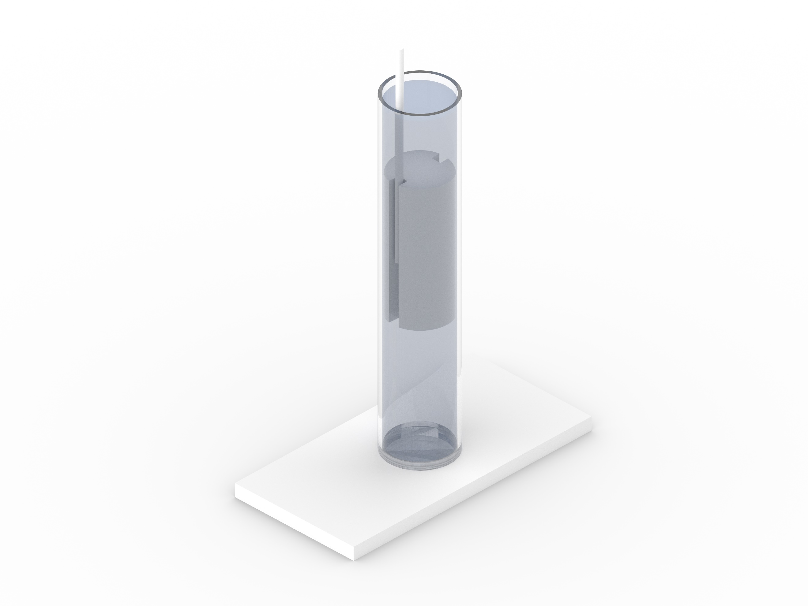

***Figure 1.*** *Schematic of an oxygenated system in a 10 mm NMR tube with D. magna. The black arrow indicates the active flow of current from movement of oxygen bubbles.*

Dual Slit Adapter



The system’s design involves two core components: a dual slit adapter and an oxygen generator. The addition of oxygen gas forms bubbles which rise and leave an area of reduced pressure that pulls in water from above the double slit and down into the chamber that contains the *Daphnia* (Figure 1). The result is a constant flow of oxygenated water over the organism, operating solely from one oxygen line.

To evaluate the efficacy of the system, lactic acid, a metabolite that is strongly associated with anoxic stress in *D. magna*, is observed in the presence and absence of oxygen by time-resolved monitoring using 1H NMR (Figure 2). Without oxygen, there is a large build-up of lactic acid after 10 hours. However, with a continuous supply of oxygen, there is no lactic acid even after 22 hours of exposure.



***Figure 2.*** *1H NMR spectra of D. magna (n = 40) in the presence and absence of oxygen exposure. Lactic acid is observed (grey box) in absence of oxygen exposure.*

1H NMR Spectrum (ppm)

1H NMR Spectrum (ppm)

1H NMR Spectrum (ppm)

Start (t = 1 hr)

No Oxygen Pump (t = 10 hrs)

Oxygen Pump (t = 22 hrs)

The oxygenated flow system is designed for *in vivo* solution-state NMR, for both large and smaller diameter probes with potential applications in toxicity and metabolomics-based research.

**Soil organic matter biogeochemical trajectories are altered uniquely with 66 years of litter manipulation in forests**

*Isla Wrightson and Myrna Simpson*

Global forest productivity has been altered greatly through climate and anthropogenic changes. Although extreme drought and temperature have lowered forest productivity in some regions, increased productivity has been observed in many forests over the last few decades due to increases in atmospheric CO2, temperature, nutrient deposition, and lengthened growing seasons. Shifts in the composition and storage of soil organic matter (SOM) are also mainly attributed to the perturbations in the quality and quantity of plant inputs to the soil that accompany these changes in productivity. Furthermore, soil carbon (C) is not linearly related to detrital inputs as increased inputs do not always increase soil C storage. Elevated plant inputs can induce soil respiration and the activation of microbes, destabilizing the stored SOM and therefore decreasing soil C storage in a process referred to as soil priming. This is in contrary to assumptions made by early soil C models, thus making predictions about future trends in soil C sequestration in response to global change drivers difficult. To study the long-term compositional changes to SOM in response to detrital changes, soil samples were collected from the University of Wisconsin (UW) Arboretum after 66 years of experimental treatments. The samples will be characterized using targeted SOM compound analyses and nuclear magnetic resonance (NMR) spectroscopy. These complementary methods are able to discern changes in SOM composition and degradation state and collectively, the results from this project will provide unprecedented insight to biogeochemical processes occurring at the molecular-level at the UW Arboretum.

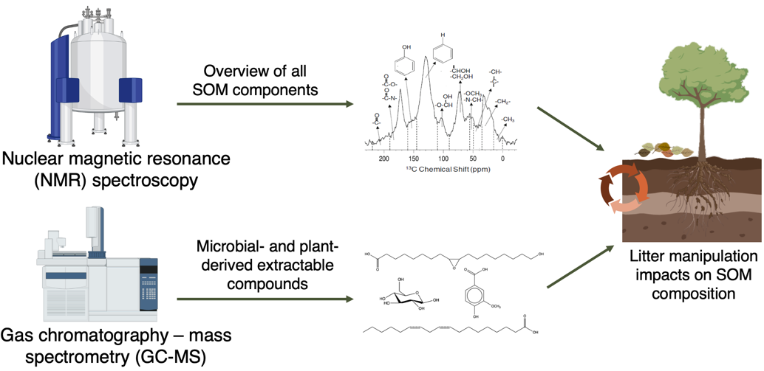

**Aqueous nitration of phenols with dissolved nitrite: a formation mechanism of atmospheric brown carbon**

*Yutong Wang and Jonathon Abbatt*

Light-absorbing organic compounds found in atmospheric particles are commonly referred to as brown carbon (BrC), with nitrophenols being a major contributor. The production of nitrophenols typically occurs via direct emissions or through photochemical reactions involving phenols and radicals like OH, NO2, and NO3. In this study, a dark pathway for nitrophenol production is explored, which involves aqueous HONO/NO2- and proceeds without apparent formation of OH radicals. The reaction kinetics of a model aqueous system comprising of catechol and NO2- are characterized using high-performance liquid chromatography-mass spectrometry (HPLC-MS) and UV-Visible spectrometry. The rate of reaction is observed to increase from pH 4.4 to pH 3.4, along with a darkening of the solution. Nitrocatechol, the first-generation nitration product of catechol, is shown to undergo later-generation reactions, producing additional chromophores with an absorption mode in the visible region (425 nm). The generality of this reaction is demonstrated using aqueous wood/peat smoke extracts through aerosol mass spectrometry (AMS) and UV-visible spectrometry, with both extracts exhibiting an increasing N:C ratio and enhanced mass absorption coefficient (300 to 500 nm) upon aqueous nitrite addition. The study also investigates the effect of droplet evaporation, a physical aging process that aerosols and cloud droplets go through, on this nitration mechanism, and the conditions under which this pathway for BrC formation is more prevalent.

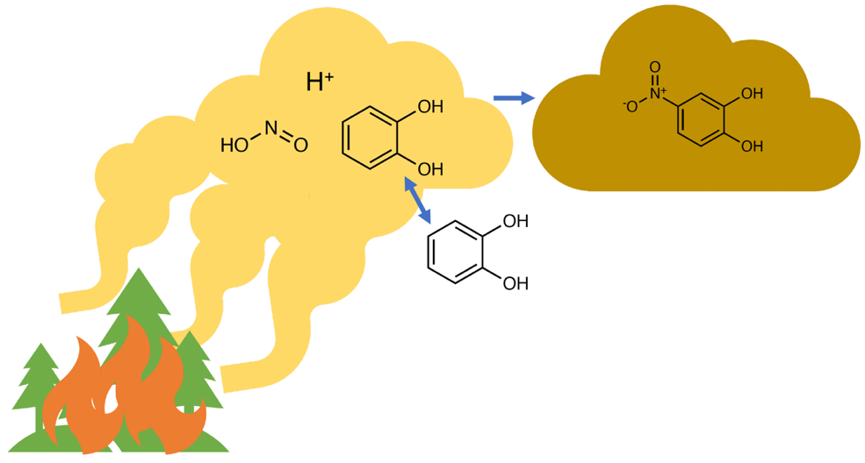

***Figure 1.*** *A demonstration of BrC aerosol darkening caused by the reaction with dissolved HONO.*

**An analysis of nitrate reactivity with volatile organic compounds across Canada**

*Brendan O’Connell and Jennifer Murphy*

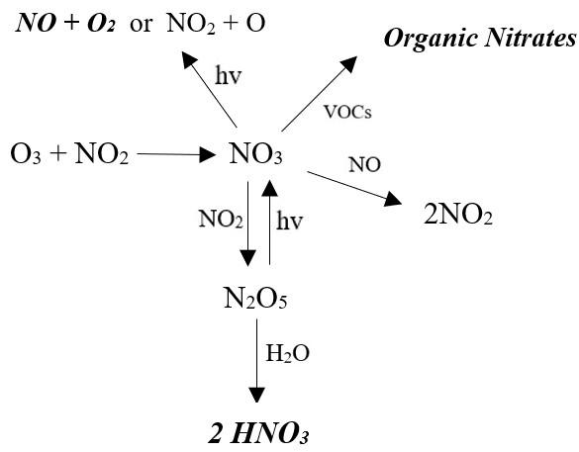The nitrate radical (NO3) is a strong oxidant, which can react with a wide array of Volatile Organic Compounds (VOCs), particularly unsaturated compounds, leading to a permanent loss of odd oxygen. Alternatively, NO3 can react with NO2 to form N2O5, which may be taken up on aerosol to form particle nitrate. However, NO3 can also react with NO or photolyze to reform NO2, thus recycling nitrogen oxides. This work focuses on calculating the pseudo first order loss rate of NO3 with VOCs to determine which reaction pathway dominates in the urban atmosphere. The nitrate reactivity is calculated by summing the products of the concentration of each VOC with its rate constant against NO3. The data used in this study is from the National Air Pollution Surveillance (NAPS) program which monitors VOC concentrations using 24-hour integrated observations collected every six days at monitoring sites across Canada between 1995 and 2020. Analysis found that the overall reactivity of NO3 with VOCs has declined with time due to decreasing concentrations of reactive VOCs in urban settings. Two key VOCs, naphthalene and 2-methyl-2-butene, have historically dominated reactivity with NO3 but their dominance is declining due to decreasing concentrations. α-Pinene and D-Limonene are the next most reactive VOCs, and are becoming more important with time in terms of total NO3 reactivity. While the absolute reactivity of VOC towards NO3 has decreased, its importance as a sink has likely increased in relative terms due to simultaneous decreases in NOx.

***Figure 1.*** *Major nitrate radical reactions in the troposphere. Compounds in bold represent the loss of odd oxygen (Ox).*

**2D 1H-13C experiments for targeted analysis of structural sub-classes *in-vivo***

*William Wolff and Andre Simpson*

*In-vivo* NMR is a powerful tool for tracking the biochemical responses of organisms in response to environmental stress but has been limited by poor resolution as a result of the extreme inhomogeneity of living organisms, and in the chemical complexity of an organism. Targeted pulse programs can support environmental studies, but often discard information that might be useful in understanding the mode of action of environmental stressors. To address these challenges, we introduce two new targeted pulse sequences: an in phase anti-phase (IPAP) HSQC to separate amides and acids alongside a conventional HSQC, and a 2D HCCH-TOCSY to obtain additional correlations whilst maintaining high resolution in a narrow band.

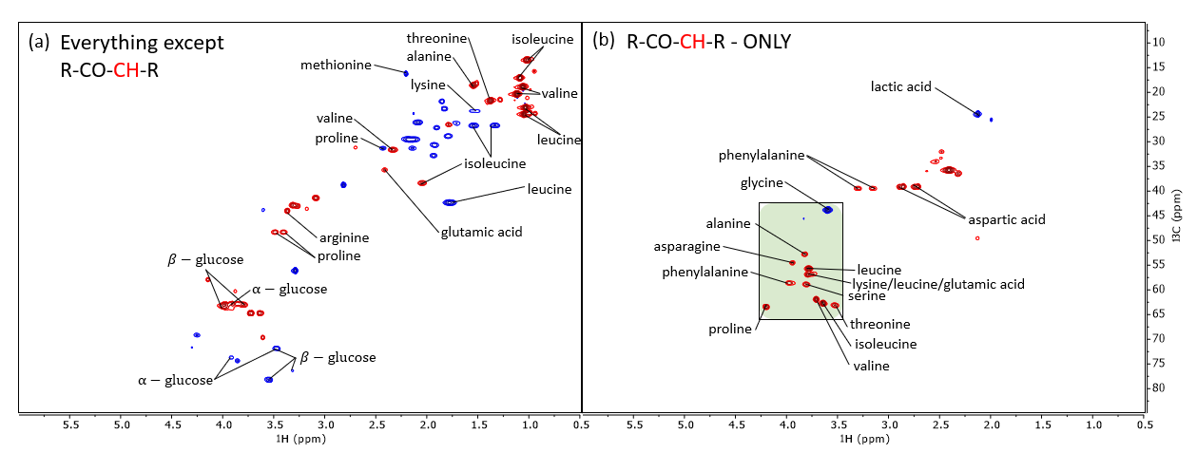

***Figure 1.*** *Carbonyl edited constant time HSQC applied to ex-vivo uniformly 13C-labelled D. magna processed to produce the sum (a) and difference (b) from the IPAP acquisition scheme. (a): the “remaining” signals not selected by the scheme (b): amino acid and organic acid signals. The green box in (b) highlights the α-amino acid region. Assignments generated from Bruker Bio-reference databases 2-0-0 through 2-0-5.*

**Evaluating land-atmosphere fluxes of nitrogen species in the Canadian Earth System Model**

*Gavin McCurdy and Jennifer Murphy*

My research is focused on evaluating the representation of land-atmosphere nitrogen fluxes in the Canadian Earth System Model (CanESM), specifically working with the Canadian Land Surface Scheme Including Biogeochemical Cycles (CLASSIC) model, which is the terrestrial component of CanESM. A nitrogen cycle was recently added to the carbon cycle framework in the CLASSIC model. The main objective is to assess whether the emissions of N2O, NO, and NH3 produced by CLASSIC can be used as inputs to the atmospheric model when the two modules are fully coupled. These gases play important roles in ozone depletion, oxidative capacity and climate forcing within the atmosphere, but their emissions are typically prescribed in atmospheric models. I am running a single-site version of CLASSIC at a few locations with Fluxnet (meteorological) data to compare the relative importance of internal and land-atmosphere fluxes of N. In a 15-year simulation at the University of Michigan Biological Station, annual emissions of N2O (0.52 kg N ha-1 a-1), NO (0.55 kg N ha-1 a-1), and NH3 (0.89 kg N ha-1 a-1) accounted for only a small fraction of the total conversion of soil NH4+ and NO3-. The emissions of NO during the month of July (3.2 g N ha-1 d-1) are larger than observations at the site (between 0.6-1.2 g N ha-1 d-1). All three species’ emissions remain relatively low and constant from September through April, increase sharply in May, and remain high during the summer months (June-August).

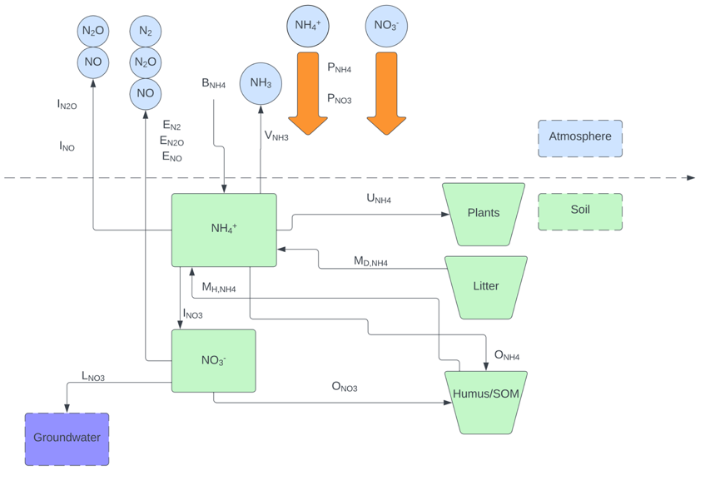

***Figure 1.*** *Simplified diagram of the nitrogen cycle implemented in CLASSIC*

**The Influence of polar bears' catabolic state and dietary composition on the potential biomagnification of PCBs**

*Yuhao Chen and Frank Wania*

Passive equilibrium sampling (PES) is a powerful tool to noninvasively derive the thermodynamic limit to an animal’s gastrointestinal biomagnification capability (BMFlim) by determining the ratio of the products of the volume (*V*) and fugacity capacity (*Z*) of undigested and digested food. By utilizing PES, we have identified a high-fat diet and a high digestion efficiency as the two primary contributors to a high BMFlim. This led us to hypothesize that an organism’s catabolic state can influence its BMFlim. Cooperating with the Toronto Zoo, we were able to study how an individual polar bear's BMFlim responds to seasonal changes in dietary composition and catabolic state (the bears fast from December to June and feast from July to November). Juno, the youngest bear, served as a reference since her diet varied only little sasonally. Juno's BMFlim reached a peak of ~60 in March and dropped to ~37 in July and November, mainly due to a decrease in the daily dietary ingestion rate (*G*food). The BMFlim of Aurora and Nikita also peaked in March, at 244 and 60, respectively, but decreased to a minimum of 39 and 12, respectively, in July before rising again to 61 and 50, respectively in November. Dramatic reductions in BMFlim were due to a decrease in *G*food and the dietary lipid content (causing *Z*food to decrease), while the increase in BMFlim toward the end of the fasting period was caused by a higher digestion efficiency.

**Exploring proton-only NMR experiments and filters for Daphnia *in vivo*: potential and limitations**

*Kiera Ronda and Andre Simpson*

With increasing industrialization, the environmental impacts of anthropogenic activities has become an area of growing concern. Therefore, it is essential to understand the impacts of contaminants on environmental health. NMR metabolomics has shown great potential in this area, due to its non-targeted nature and ability to analyze complex samples in their unaltered states. *Daphnia magna* are one of the key species used for these studies as they are small enough to survive inside a 5 mm NMR tube.

Due to the complexity of biological samples, 1D proton spectra have a high-degree of overlap, with extensive information buried beneath broad lipid signals. Spectral dispersion is greatly improved in 2D experiments, therefore most studies to date have used 1H-13C 2D NMR of 13C-enriched organisms. With the soaring costs of 13C-enrichment (~600%) making culturing enriched organisms much less accessible, it is important to ask, “can any meaningful information be extracted from the proton-only NMR of living Daphnia”?

To address this, two samples are evaluated. The first consist of intact lyophilized Daphnia reswollen in D2O, as the organisms produce sharper signals after death. Conversely, *in vivo*, organisms swim inside a flow system of 100% water, resulting in lipid dominated spectra. As seen in Figure 1, a wealth of information is present in the reswollen organisms and solvent suppression is trivial, whereas aggressive suppression is required for the *in vivo* sample. The costs and benefits of various proton-only experiments will be investigated to determine the extent of information that can be obtained without organism enrichment.



***Figure 1.*** *Investigating the application of no water suppression (a, d), a presaturation pulse (b, e), and a SPR-W5-WATERGATE (c, f) in an ex vivo (left) and in vivo (right) sample of D. magna.*

**Impacts of SVOCs and relative humidity on the deposition rate of ozone to permeable indoor surfaces**

*Jillian Downey and Jonathan Abbatt*

Ozone (O3) reacts with unsaturated compounds, whose reaction products, when inhaled, can result in negative health effects. For many unsaturated molecules, the surface reactivity is over 100 times that in the gas phase. Given that indoor environments have high surface area-to-volume ratios, surface reactions play a huge role in establishing indoor air quality. O3 loss rates on single-component, clean surfaces have been well studied. However, the indoor environment is complex, with many surfaces being permeable and/or covered in semivolatile organic carbons (SVOCs). Diffusion rates of O3 into permeable surfaces depend on RH, and the partitioning of SVOCs may also be affected by RH. This suggests that RH will affect O3 reactivity, however, an understanding of these processes is limited. This work addresses how O3 deposition on a permeable surface (painted surface) is affected by a model unsaturated SVOC (terpineol) at different RHs. Firstly, to quantify O3 deposition on a painted surface, O3 was passed through a chamber (with painted surfaces on the top and bottom) and O3 was monitored at varying RHs. Then, terpineol uptake on a painted surface was quantified by measuring the sorbed mass of terpineol using an online mass spectrometer at different RHs. Lastly, O3-terpineol reactivity was studied, where O3 was introduced to a terpineol-conditioned chamber and was monitored at varying RHs. It was found that increased RH increases O3 deposition and terpineol partitioning into the paint. Also, the presence of terpineol increases ozone deposition, emphasizing the importance of SVOC-O3 surface reactions on indoor air quality.

**Exploring the potential of broadband complementary metal oxide semiconductor micro-coil nuclear magnetic resonance for environmental research**

*Daniel Lysak and Andre Simpson*

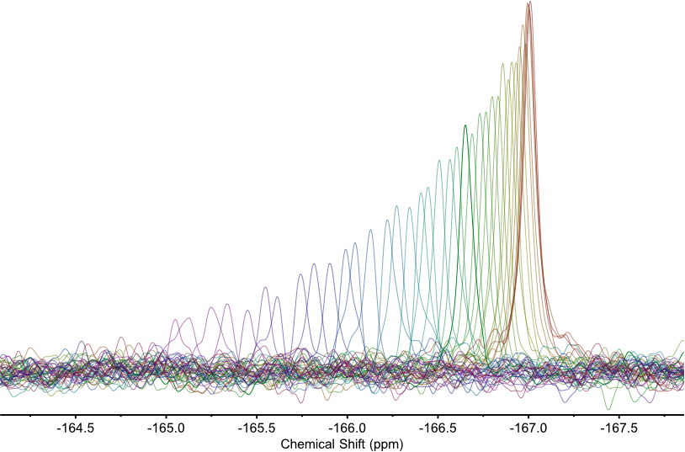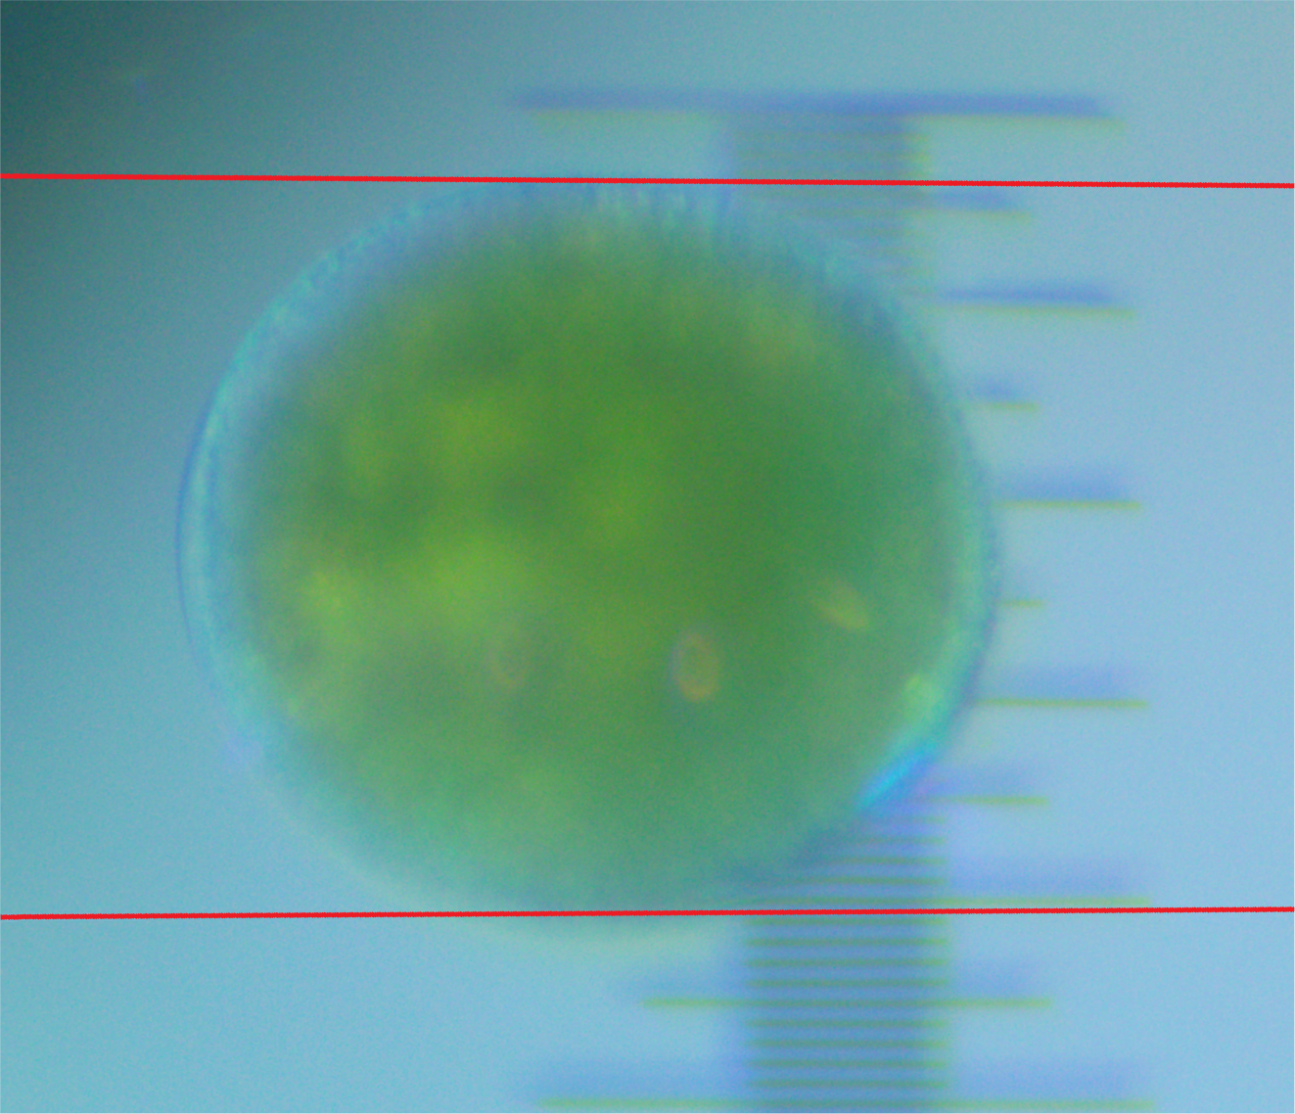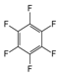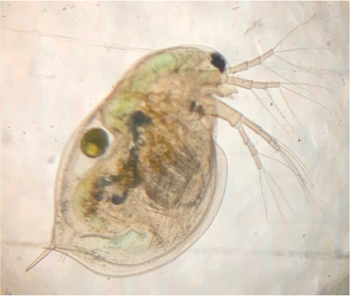

**Figure 1**. A time series of the 19F NMR signal corresponding to hexafluorobenzene from a single Daphnia magna egg. The red trace is the first time point, with increasing time resulting in a decrease in signal and downfield chemical shift. The inset shows a microscope image of a Daphnia magna and egg.

With sensitivity being the Achilles’ heel of nuclear magnetic resonance (NMR), the superior mass sensitivity offered by micro-coils can be an excellent choice for tiny, mass limited samples such as eggs and small organisms. Micro-coils with sizes in the range of 100s of microns have been reported to have mass sensitivity values orders of magnitude higher than standard 5 mm probes, allowing for improved NMR analysis of tiny samples.

A recent trend in microcoil NMR has been the use of complementary metal oxide semiconductor (CMOS) based microchips which include an integrated circuit containing all transceiver electronics. This “NMR on a chip” approach provides several advantages over micro-coils interfaced to discrete electronic components including: excellent sensitivity, the ability to have a broadband coil for analysis of heteronuclei, decreased parasitic losses by eliminating coil leads, and easy expansion to multiple coils on a single chip, allowing increased sample throughput or concurrent analysis of different samples. Here, the potential of CMOS based devices for environmental research is investigated.

Numerous heteronuclei such as 7Li, 11B, 13C, 19F, 23Na, 27Al, 31P, and 205Tl were detectable and 13C and 19F were used to study two environmental samples: a sprouting broccoli seed and a single *Daphnia magna* egg. The *D. magna* egg was exposed to hexafluorobenzene, and the contaminant was monitored within the egg by 19F NMR (Figure 1). Overall, broadband CMOS microcoils are shown to have significant potential for environmental research.

**Investigating the impacts of warming and nitrogen-addition on soil-derived dissolved organic matter**

*Atzín San Román and Myrna Simpson*

Dissolved organic matter (DOM) can account for as much as 5% of the soil organic matter (SOM) found in forest soils. DOM represents the most mobile and reactive carbon (C) fraction in forest soils, and it plays an important role in global C cycling, helping to transport nutrients within soil profiles and throughout aquatic systems. However, several aspects of global environmental change amplified by human activities, such as increased temperatures and nitrogen (N) deposition, can alter soil microbial communities, and the biogeochemistry of DOM. Yet, there is still a lack of molecular-level understanding of the biogeochemical perturbations to the C cycle with respect to global environmental change. Thus, this study aims to identify how warming, N-addition, and warming + N alter DOM chemistry and cycling. To investigate this, samples from the soil warming and nitrogen (SWaN) study at the Harvard Forest Long-term Ecological Research site are analyzed after 4, 10, and 14 years of treatment (warming, N-addition, and warming + N). The samples are characterized via nuclear magnetic resonance (NMR) spectroscopy to evaluate changes in the composition and degradation of DOM in response to environmental changes. It has been noted that N-addition can slow SOM decomposition while warming and warming + N can accelerate decomposition. Thus, we expect to see similar trends with DOM where warming + N will mirror warming, but not to the same extent. Overall, this study will provide molecular-level insight into the unique impacts of different environmental stressors on forests, both separately and simultaneously.

**Atmospheric reaction in single levitated droplets under variable humidities**

*Chris Rusiewicz and Jamie Donaldson*

Carbonaceous aerosols like Black carbon (BC) contribute considerably to positive radiative forcing. Within the last two decades a new classification has arisen describing a highly wavelength dependent organic aerosol termed Brown carbon (BrC). Primarily emitted from biomass burning, BrCs exact contribution to the radiative budget and its fate inside the atmosphere are not fully understood. Previous work from our group using acoustically levitated droplets containing water soluble pine wood smoke showed a red shift in the absorbance spectra that was partially attributed to heterogeneous photochemistry in the presence of molecular oxygen. However, those experiments were carried out under very low humidities, thus photo-oxidation occurred at the same time as evaporation, complicating results. I have focused on increasing the relative humidity to the deliquescence point of atmospherically relevant inorganic salts to achieve a stable droplet. Droplets containing Phenol Red can be easily measured by UV-vis absorption, and it was found that droplet volume and spectroscopic measurements could be made stable over time spans of hours. Introducing gaseous acid or base into the chamber will induce a detectable and quantifiable pH shift which will be the next objective. The ultimate future work will focus on quantifying the observed red shifts in levitated droplets by using well-defined BrC components and determining reaction pathways leading to the observed red shift through composition analysis by high resolution mass spectrometry.

**DREAMTIME NMR of slow spinning systems using High-Resolution-Magic Angle Spinning**

*Rajshree Ghosh Biswas and Andre Simpson*

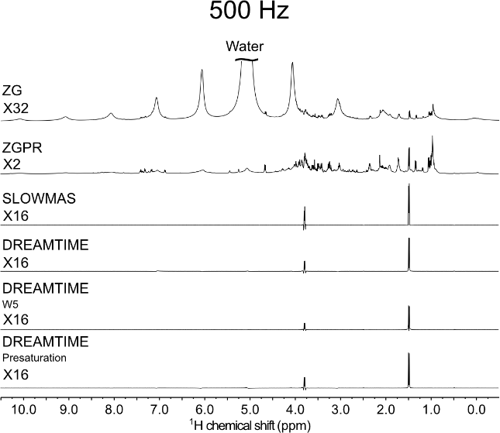

NMR spectroscopy is a powerful analytical technique providing molecular-level information in complex samples, non-invasively. However, NMR suffers from some limitations, including low sensitivity, and large spectral overlap from multiple chemical structures with similar resonance frequencies. Moreover, due to magnetic susceptibility distortions arising from inhomogeneous samples (gel-like tissues, solution-like biofluids), signal broadening makes discerning metabolite information difficult. High-Resolution-Magic Angle Spinning (HR-MAS) alleviates this by spinning samples at high speeds (KHz range) to dramatically narrow lineshape and improve sensitivity. However, at such high spinning speeds (>3000 Hz), biological tissue of organisms tends to rupture thereby making *in vivo* monitoring difficult. Thus, organisms must be spun slowly to improve their survival. For example, at 2500 Hz, freshwater shrimp (*Hyalella azteca*) can survive up to 14hrs, whereas at 500 Hz, this improves to ~ 48hrs. Moreover, organisms must be maintained in a rotor of water to ensure their survival and reduce magnetic susceptibility distortions. Unfortunately, at reduced spinning, spectral overlap, water resonances and spinning artifacts (spinning sidebands), hinders isolating and assigning specific metabolites. To alleviate this, we apply the novel DREAMTIME NMR technique to selectively isolate individual and multiple metabolites from complex heterogenous mixtures under slow spinning, with improved sensitivity. This study also introduces a new variation of DREAMTIME (SLOWMAS) designed specifically for slow spinning to supress the broad water resonances and its subsequent sidebands for *in vivo* monitoring. Here, DREAMTIME SLOWMAS will be demonstrated for the first time, using *ex vivo* worm tissue and compared to traditional DREAMTIME NMR and water suppression techniques.

***Figure 1****. Selective detection of alanine using DREAMTIME and SLOWMAS in a worm, ex vivo, at 500 Hz under MAS*

**Photoreaction aging of biomass burning brown carbon**

*Carolyn Liu-Kang and Jonathan Abbatt*

Biomass burning brown carbon (BrC) has been shown to significantly impact global climate by influencing Earth’s radiative balance. It’s ability to absorb light in the visible and ultraviolet regions contributes to warming effects. However, a wide range of aging mechanisms in the atmosphere can alter the composition and corresponding optical properties of BrC, in both the aqueous and particle states. Due to BrC’s chemical complexity, as well as these many aging processes, the contribution of BrC to overall aerosol light absorption to remain highly uncertain. Isolating each individual aging mechanism is key to understanding the global picture of BrC’s behavior during its residence time in the atmosphere.

In this study, the link between the chemical composition and the absorption properties of BrC from photoreaction, i.e., light exposure, was investigated in both the aqueous phase and the particle state. Pine wood was smoldered in-lab as the source of wood smoke particles, followed by aging from ultraviolet light exposure directly on filters (particle state), or after extraction in water (aqueous phase). Changes in the optical properties were observed with a UV-visible spectrophotometer, while potential radical formation was monitored with an EPR (Electron Paramagnetic Resonance) spectrometer. In addition, information on chemical composition before and after aging was obtained with mass spectrometry techniques. Initial results show an absorption enhancement following light exposure at short timescales. Further investigation into concomitant reactants in play indicate the important role of molecular oxygen in this aging mechanism, whereas hydroxyl radicals do not play a role.

**Evaluation of irradiated Wyoming-type bentonite natural organic matter at varying moisture levels**

*James Neurauter and Myrna Simpson*

Wyoming-type bentonite clay (MX-80) has been selected by Canada’s Nuclear Waste Management Organization (NWMO) as a deep geologic repository buffer material. These bentonites are intended to facilitate the isolation of used nuclear fuel and prevent radionuclide release as an adsorbent. Water and natural organic matter (NOM) are present in mined bentonite clays, and the latter may serve as a source of nutrients for microbial activity, potentially inducing used fuel container corrosion over time. As the proposed deep geologic repository buffer material, Wyoming-type bentonite will be subjected to irradiation due to its proximity to used fuel containers. This renders the radiolysis of water a concern, as it promotes the formation of products capable of oxidizing NOM and potentially accelerating microbial degradation. While the diagenetic alteration of Wyoming-type bentonite NOM has been noted, there is limited knowledge concerning the sensitivity of NOM chemistry to irradiation at different water contents. To investigate this further, molecular-level techniques were employed to assess compositional differences of irradiated (100 kGy for 3 days) Wyoming-type bentonite NOM samples with gravimetric water content levels ranging from 20% to 80% of the sample mass. The total, organic, and inorganic carbon concentrations were determined via elemental analysis while solid-state NOM evaluation was conducted via 13C nuclear magnetic resonance (NMR) spectroscopy, and targeted compound analysis was performed via gas chromatography-mass spectrometry (GC-MS). This project will determine whether products of water radiolysis increase the chemical reactivity of Wyoming-type bentonite NOM, contributing to the substantiation of safe and reliable used nuclear fuel storage.

**Integrated screening of bioactive contaminants contributing to the high receptor activities in St. Lawrence beluga whales**

*Holly Barrett and Hui Peng*

While elevated tissue concentrations of pollutants have been reported in St. Lawrence Estuary (SLE) belugas, the exact bioactive chemicals exerting toxicity remain unknown. We integrated chemical analysis and receptor activity screening to identify contaminants of potential toxicity in SLE beluga liver and blubber and reference Arctic beluga blubber.

Contaminants were extracted from pooled tissue of whales found stranded from 1990-2017. Extracts were analyzed by mass spectrometry, and results were matched to a database of known bioactive chemicals (Tox21). ~200 matched compounds were significantly more abundant in the SLE tissue than Arctic tissue. Extracts were tested for their activity towards the AhR receptor to investigate the contribution of known and unknown chemicals towards AhR-mediated responses, and significant responses were detected (*e.g.,* 0.16 g/mL liver induced AhR). Consistent with the more diverse chemical burden found in SLE belugas, SLE tissue exerted significantly higher AhR activity than Arctic blubber. Several AhR-active compounds detected through Tox21 screening were found to partially explain the SLE activity, including natural indoles and synthetic dyes. The extracts were then screened against a suite of 48 human nuclear receptors (NRs), revealing significant activities for several NRs. Distinct from Arctic blubber, the SLE extracts exerted significant activity towards several NRs with functions in cancer progression, such as the pregame X receptor (PXR). These results mark the first time that receptor activity has been measured for SLE belugas. Ongoing work focuses on using affinity pulldown nontargeted analysis (APNA) to confirm the ligands responsible for the activity of PXR and other NRs.

**NMR in an eggshell – *in vivo* carbon tracing and embryogenesis study of Society Finches**

**Figure 1.** Egg incubator in a 15 mm NMR tube.

*Katrina Steiner and Andre Simpson*

*In vivo* NMR is an insightful and powerful analytical technique that permits the “real-time” analysis of samples in their natural and unaltered states. These criteria are especially important when studying intact biological samples and living organisms. A particularly interesting application of *in vivo* NMR is in embryo developmental studies. Limited *in vivo* NMR embryogenesis studies have already been done on small amphibian and aquatic eggs, and even less on mammalian eggs. The research presented here aims to investigate carbon transformation pathways during embryo development of Society Finch bird eggs via *in vivo* NMR techniques. Bird eggs are an excellent model for environmental studies as they are highly sensitive to environmental changes.

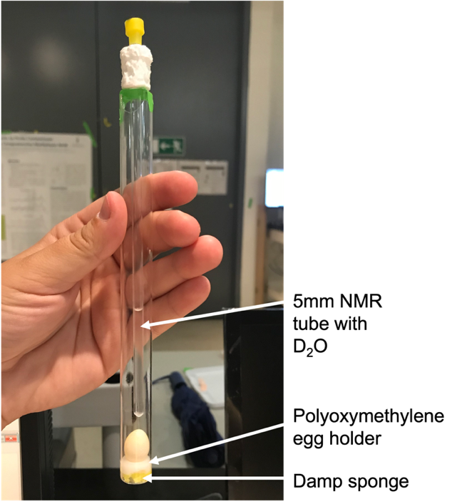

A custom egg incubator (figure 1) is designed in a 15 mm NMR tube to: (1) maintain proper humidity for egg development, (2) prevent egg movement while inside the spectrometer, and (3) allow for instrument locking using a D2O lock bulb. Radiofrequency pulsing and powerful NMR gradients have the potential to cause sample heating which can be problematic when studying biological systems. Thus, before analysing fertilized bird eggs which are sensitive to temperature change, it’s important to identify and eliminate such heating. Next, fertilized bird eggs are analyzed using various 1D and 2D solution state NMR experiments combined with filters and spectral editing to target metabolites of particular sizes. Eggs are analyzed from day 1 of fertilization to near hatching. Results of this study additionally have the potential to provide the foundation for future embryotoxicity testing using environmental contaminants.

Haloacetonitrile toxicities attributed to distinct reactions with proteins thiols

*Kirsten Yeungand Hui Peng*

Disinfection by products (DBPs) are formed in disinfected/santized water which have been correlated with incidences of disease such as bladder cancer and adverse pregnancy outcomes. Recently, haloacetonitriles (HANs) have been highlighted as an emerging DBP with stronger toxicities than regulated DBPs. This talk will elucidate the toxicity mechanisms of HANs, including monoHANs and polyHANs, by investigating their reactivity with protein thiols. Despite the ’simple’ structures of HANs, 3 disinct reaction pathways were observed which were attributed to the various toxicities depending on the type and number of halogens present. Both substitution and addition reaction pathways will be discussed. Cytotoxicity and oxidative stress bioassays were employed to determine the ability of various HANs to induce toxic effects and the role of each HANs’ preferential reaction pathway in predicting harmful effects in the human cell. The descending toxicity rank order by using reporter cell systems is as follows: iodoacetonitrile ≈ dibromoacetonitrile, bromoacetonitrile, trichloroacetonitrile ≈ chloroacetonitrile ≈ dichloroacetonitrile. Activity based protein profiling (ABPP) was used to image *in vitro* HAN adduction effects on protein thiols in human cells. The ABPP rank order was similar to that of the oxidative stress assays with differences among the low/no-toxicity chlorinated species. The strong toxicity of dibromoacetonitrile is unexpected, due to its unexpected debromination and substitution reaction pathway(s) which were probed by both mass spectrometry and NMR.



**Figure 1.** Substitution and addition reaction scheme between polyHANs, monoHANs and GSH.

**Observing secondary organic aerosol formation from oxidation of cannabis smoke**

*Kristen Yeh and Jonathan Abbatt*

Exposure to ultrafine fine particles (UFP) may lead to significant health impacts due to their small particle size and high deposition efficiency in the lower respiratory tract. Early studies of primary emissions from cannabis smoke have identified several gaseous compounds which have the potential to react with atmospheric oxidants. These reactions form less volatile species which may contribute to secondary organic aerosol (SOA) and UFP formation. Whether SOA and UFP formation occurs during oxidation of cannabis smoke remains to be investigated. This work aims to fill existing knowledge gaps by characterizing the particle size distribution of primary aerosols emitted from cannabis smoke and observing secondary organic aerosol formation when smoke is exposed to ozone (O3). Cannabis smoke was introduced to an environmental chamber connected to instruments for characterization of particle and gas-phase emissions. For analysis of primary aerosols, smoke was added to a chamber containing less than 5 ppb O3. When observing SOA, smoke was added to a chamber containing approximately 100 ppb O3. Prior to ozone exposure, primary aerosol mass concentrations were comparable to aerosol concentrations previously observed in primary cigarette smoke. After ozone exposure, aerosol mass concentrations were observed to increase. Additionally, a new mode of particles in the ultrafine diameter range was detected after ozone exposure. The diameter of the newly formed particles was observed to increase over the aging period.

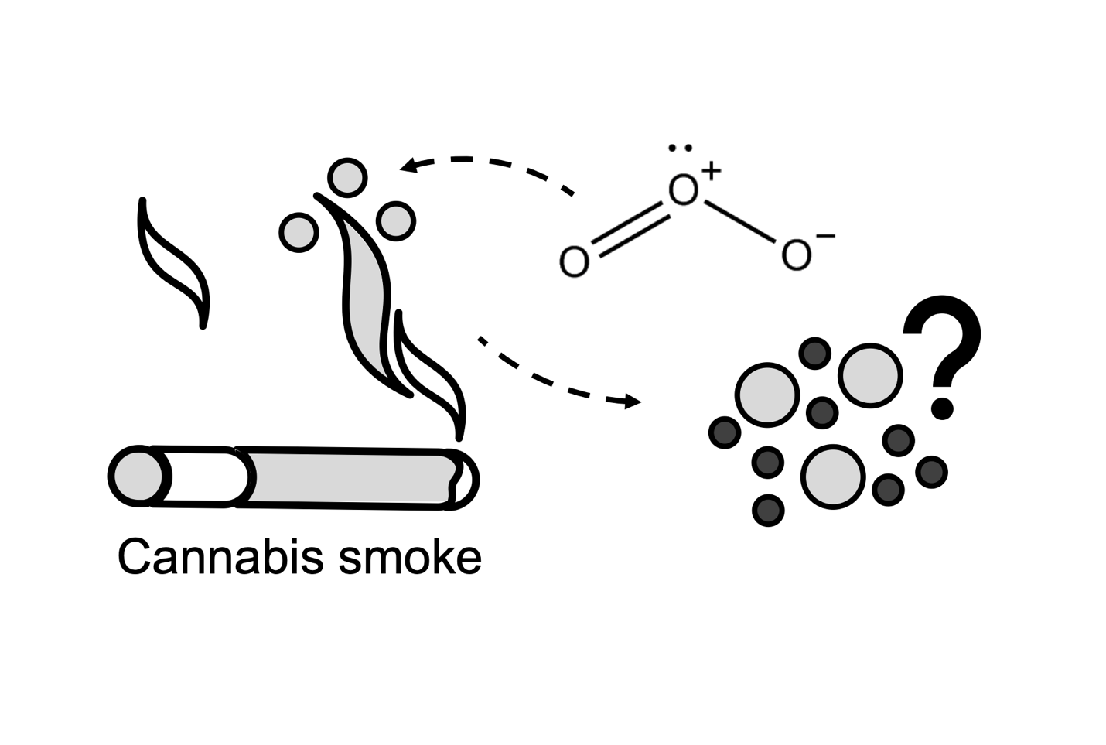

**Fate of the azole fungicide fluconazole in sunlit waters: kinetics, transformation products, and reaction mechanisms**

*William Fahy, Jonathan Abbatt, and Scott Mabury*

The common antifungal pharmaceutical fluconazole is a persistent organic pollutant regularly found contaminating bodies of water around the world. Fluconazole can cause adverse health effects to at environmentally relevant concentrations and has been shown to inhibit the human cytochrome P450 system, which could slow metabolism of other xenobiotics and lead to synergistic toxic effects. Little is known about the environmental fate and transformations of fluconazole, although existing work on biodegradation and advanced oxidation processing indicates it is recalcitrant to many natural transformation pathways. Here we used the PhotoFate system to investigate the indirect photolysis of fluconazole in simulated sunlit freshwater environments. We estimate a half-life with respect to indirect photolysis in natural waterways ranging from around 5 to 25 days, with faster degradation observed with high concentrations of dissolved organic matter and/or nitrates. Transformation products have been identified and semi-quantified using liquid chromatography coupled to (high resolution) mass spectrometry with major products observed including multiple OH addition isomers, breaking of the bridging alkyl chain, and aromatic ring opening. Tentative structures and reaction mechanisms to produce those structures are proposed based on exact mass analysis, retention time analysis, and previous observations of hydroxyl and carbonate radical reactivities in aqueous solutions. Finally, the photoproduct mixture was tested for inhibition of the *in vitro* metabolism of bisphenol A by human cytochrome P450s. Our results indicate that fluconazole is persistent in natural waters and that slow natural indirect photolysis results in toxic and likely persistent transformation products.

**Avoiding regrettable replacements: can the introduction of novel functional groups move PFAS from recalcitrant to reactive?**

*Andrew Folkerson and Scott Mabury*

Per- and polyfluoroalkyl substances (PFASs) are a class of compounds present in a range of commercial and consumer products. These chemicals are often highly performing surfactants or non-stick/water repellant coatings due to their innate chemical stability; however, due to this stability select PFAS can be environmentally persistent. A novel group of commercial surfactant building blocks (F7C3-O-CHF-CF2-S-EtOH (FESOH), F3C-O-CHF-CF2-S-EtOH (MeFESOH), F7C3-O-CHF-CF2-O-EtOH (ProFdiEOH), F7C3-O-CHF-CF2-CH2-OH (ProFEOH), F3C-O-CHF-CF2-O-EtOH (MeFdiEOH)) have been developed with heteroatom linkages such as ethers and thioethers, and polyfluorinated carbons, to facilitate degradation. The differing degradation rates and products of these chemicals were investigated in an atmospheric chamber to investigate their behaviour to inform their fate in the environment. The complete fate of each molecule was studied through both online high-resolution mass spectrometry via chemical ionization time of flight mass spectrometry (CIMS-ToF), and off-line bubblers to extract any acidic products for targeted identification and quantification via ultra-high performance liquid chromatography-tandem mass spectrometry (UPLC-MS/MS). FESOH and MeFESOH, the two compounds with a thioether, were observed to have the shortest atmospheric lifetimes, through OH radical oxidation, of 4.03 and 5.24 days respectively. Interestingly, this additional trend of longer similarly structured species reacting faster holds true for the ether species as well (ProFdiEOH and MeFdiEOH). Additionally, by monitoring the OH radical reaction with the FESOH congeners through the CIMS, we can elucidate the identity of primary, secondary, and tertiary products, and the time course of their relative abundances. Terminal acid products quantification yielded PFPrA and shorter polyfluoroether acid species as the terminal products for FESOH and ProFdiEOH, however, MeFESOH demonstrated the propensity to completely mineralize, thus demonstrating the importance of introducing these novel functional groups.

**Nitrous oxide profiles from the Canadian Atmospheric Laser Absorption Spectrometer Experiment Test-bed**

*Mark Panas and Jennifer Murphy*

The Canadian Atmospheric Laser Absorption Spectrometer Experiment Test-bed (CALASET) project aims to produce high quality profiles of trace gases in the atmosphere using in-situ laser spectrometers on high altitude ballon platforms. Vertical profiles of trace gases are important for validating remote-sensing measurements. Two CALASET instruments for measuring greenhouse gases were flown in an August 2022 field campaign in Timmins, ON. Results from one of the spectrometers will be discussed here. This instrument is capable of measuring CO2 and N2O, but the CO2 retrieval was unsuccessful due to the choice of spectral window. Additionally, significant optical interferences and difficulty in predicting the laser background hampered the retrieval of gas concentrations. Nevertheless, N2O profiles from approximately 100 to 10 mbar were measured during the ascent and descent portions of the flight with a precision of 1.1 ppb. There was a significant offset between the ascent and descent mixing ratios of about 20 ppb. This may be partially attributed to differences in temperature of the atmosphere during the ascent and descent. These profiles were compared to profiles from the Microwave Limb Sounder (MLS) on the Aura satellite. There was significant disagreement between MLS and both the CALASET ascent and descent profiles, and the cause of the disagreement is still unknown.

**Characterizing the oxidative potential associated with biomass burning aerosol from Canada**

*Bradley Isenor and Arthur Chan*

With climate change on the rise, the looming threat of increased wildfires and their associated pollutants, particularly particulate matter (PM), is of great concern. These small, complex mixtures of chemicals, found in smoke and other aerosols, have been linked to numerous negative health effects and recent research suggests that PM from biomass burning may be significantly more harmful than PM from other sources. While the exact mechanisms through which PM causes harm are still under investigation, the dominating view is that their deleterious effects are primarily driven by their ability to trigger oxidative stress after inhalation. To date, little research has explored PM emitted from wildfires and even less on their abilities to induce oxidative stress (i.e., oxidative potential, OP). The focus of this research is to understand if and why PM emitted from wildfires are more harmful than PM emitted from other sources. To address this research question, the composition and OP of various biomass burning PM samples from the field and the lab will be characterized. The dithiothreitol assay will be used to measure the OP of PM and will be employed alongside the electron paramagnetic resonance to identify and quantify harmful environmentally persistent free-radicals and reactive oxygen species. Finally, a chemical analysis of the PM (e.g., organic carbon, elemental carbon, and levoglucosan content) will advance the understanding of the connection between biomass burning organic aerosol and human health.

**Field observations of size-resolved particulate alkyl amines in urban Toronto during winter 2022-23**

*Xiaoying Yang and Jennifer Murphy*

Mainly emitted from anthropogenic activities, amines are N-containing alkaline compounds that play an important role in enhancing new particle formation and growth, despite their relatively low abundance in the gas phase. From October 2022 to March 2023, size-resolved particulate amines were measured using an eleven-stage micro-orifice uniform deposition impactor (MOUDI) covering aerodynamic diameters from several microns down to 0.056 μm in 23 sets of multi-day observation periods. Samples were collected with cellulose and Teflon filters, but a positive artifact was observed for cellulose filters that needs to be further investigated. Dimethylamine and diethylamine were found to be predominant amines in urban Toronto, contributing 0.1~3% of water-soluble cation charges. Their mass loadings generally maximized at ~200 nm but were highest relative to ammonium in the smallest particles. Using simultaneous measurements of gas-phase ammonia and the solubilities of ammonia and amines, the range of gas phase concentration of dimethylamine was estimated to be 10-2 ~ 10-1 ppt, which could be relevant for new particle formation; while the gas phase concentration of diethylamine was estimated to be 10-4 ~ 10-3 ppt. This observation strategy will be optimized and applied for the following summer and winter measurements this year, to elucidate the urban budget of amines throughout the year.

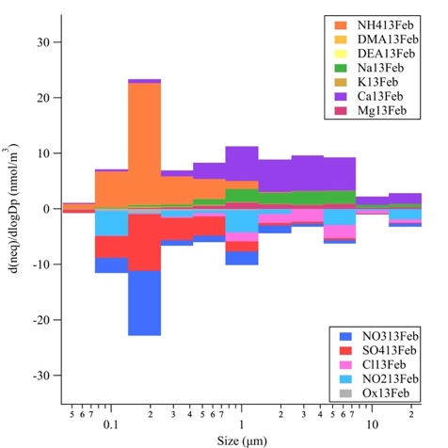 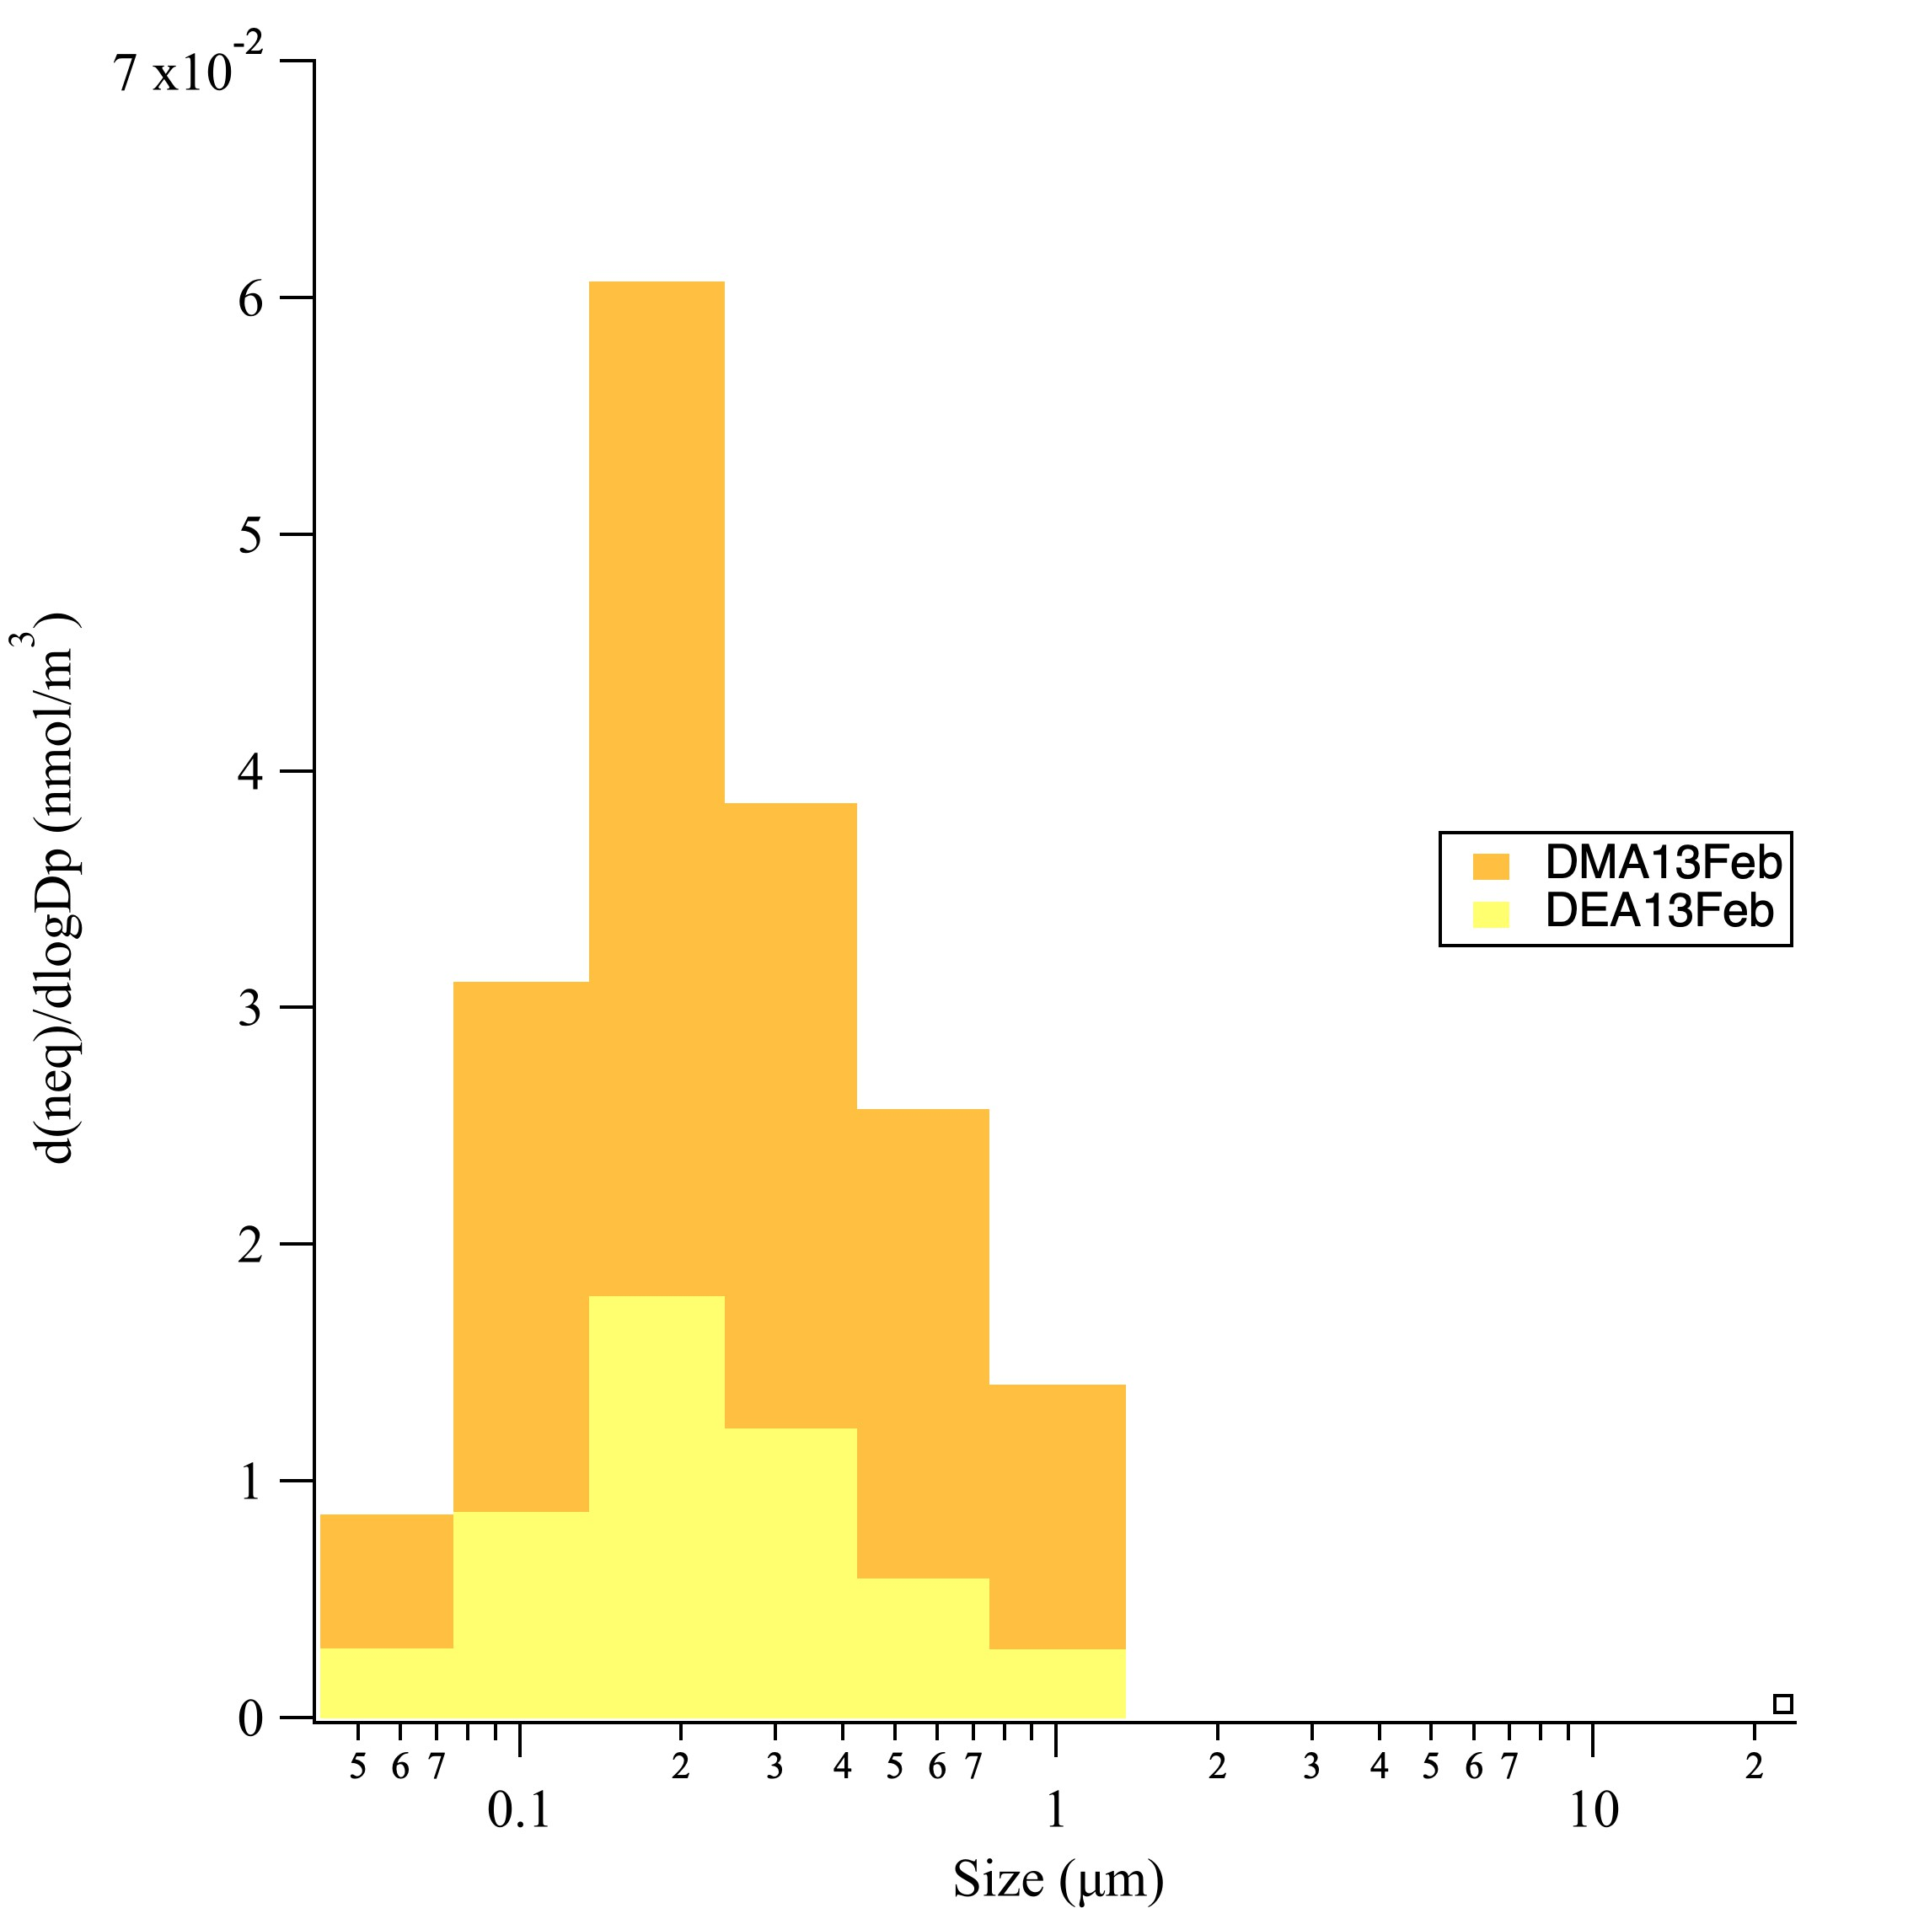

**Evaluation of adsorption isotherm models for determining the partitioning of ammonia between soil and soil-pore water in environmental samples and potential ammonia emissions sourced from Toronto’s urban greenspace**

Matthew Davis and Jennifer Murphy

Ammonia in soil pore water (spw) is thought to participate in bidirectional exchange with the atmosphere; however, common soil nutrient analysis methods determine the bulk quantity of ammonia associated with the soil particles, rather than determining the spw ammonia concentration. To estimate the proportion of aqueous ammonia in soils, previous studies have applied the Langmuir and Freundlich isotherms to ammonia-enriched soils. In this work, environmental soil samples were collected from green spaces in Toronto and used to evaluate the Langmuir and Freundlich adsorption isotherm models to determine their applicability to non-fertilized soils. We found that both models can be used to represent the relationship between the amount of ammonium adsorbed to the soil, S (mg/kg), and the bulk quantity of ammonia in the extraction solution, C (mg/L), and thereby determine the ammonia emission potential of our soil samples. By combining the equilibrium vapor concentration associated with those emission potentials with our two-year atmospheric ammonia monitoring record, we investigated the parameters and conditions under which urban greenspaces would plausibly contribute ammonia to the atmosphere. With environmental policy focusing on controlling regional sources of ammonia, further research is needed on the potential local sources that may become more influential to urban air quality in the future.

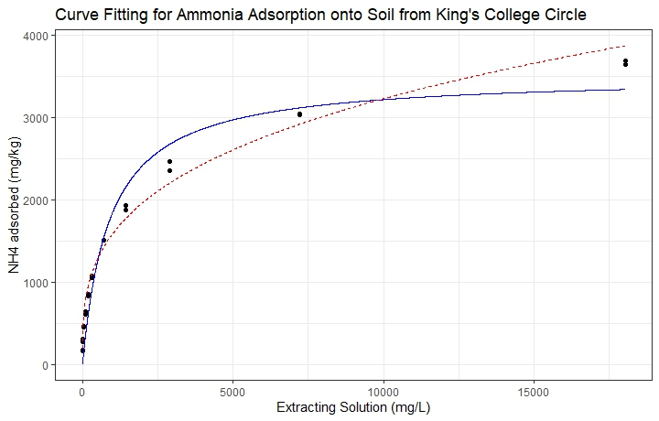

Langmuir (top) and Freundlich (bottom) adsorption isotherm equations, relating the concentration of NH3 adsorbed (A) to the aqueous concentration (C)

$$S= \frac{S_{max}k_{L}C}{1+k_{L}C}$$

$$S= k_{F}C^{nF}$$

***Figure 2.*** *Comparison of Langmuir (solid) and Freundlich (dashed) isotherms for fitting the adsorption isotherm curves of ammonium to an environmental soil sample.*

**Oxidation of bisphenol A via gas-surface ozonolysis: chemical transformation of a widespread organic pollutant**

*Jie Yu and Jonathan Abbatt*

Although bisphenol A (BPA) is a widely used chemical in food packaging and plastic consumer products, it is also a well-known synthetic estrogen that can disrupt the endocrine system. In Canada, the use of bisphenol A is banned in baby products, so a set of alternatives – structurally similar to BPA – has been developed and used in “BPA-free” products. Research on alternatives’ safety is limited but there are indications that some may also be endocrine disruptive. The ubiquitous presence of BPA and its alternatives in ambient dust and aerosol samples suggests the potential for transformation via heterogeneous oxidation with atmospheric oxidants. However, studies on the environmental fate of BPA and its alternatives are incomplete, with uncertainties remaining in the loss kinetics of the parent chemicals and in the identities and the associated health impacts of the transformation products.

This study aims to address these uncertainties by studying the gas-surface ozone oxidation of BPA under atmospherically-relevant exposure conditions, with specific focus on kinetics and transformation mechanisms. Laboratory ozonolysis was conducted for 2.5-nm-thick BPA films in a flow reactor. Degradation of BPA and growth of four oxidation products compounds were analyzed offline by LC-ESI-MS. These results are supported by exposure experiments to genuine indoor air which contains ozone, where thin BPA films and thermal paper containing BPA both showed the appearance of the products observed in the flow reactor. These results will aid in the evaluation of BPA environmental fate pathways, future studies of the toxicity of these products, and prediction of the oxidation products of BPA alternatives.

**The roles of temperature and pH in the gas-particle partitioning of ionizable organics in the atmosphere**

*Olivia Driessen and Jennifer Murphy*

Atmospheric aerosols not only impact environmental and human health, but also affect the global climate through direct and indirect radiative forcing. Improved understanding of the roles played by individual atmospheric vapors in new particle formation and particle growth is required, particularly with shifting trends in anthropogenic emissions. Traditionally, the inorganic constituents sulfuric acid, nitric acid, and ammonia have been considered to dominate water-soluble secondary aerosol, but this project aims to examine the role of alkylamines and small organic acids in aerosol formation. Potentiometric titrations were performed to determine the temperature dependence of the acid dissociation constant of several amines, which is a key thermodynamic parameter needed to predict their gas-particle partitioning. Enthalpies of dissociation were measured for ammonia (53 kJ mol-1), methylamine (55 kJ mol-1), and ethanolamine (47 kJ mol-1). Gas phase amines are recognized as potent agents of new particle formation, but their propensity to partition into acidic aqueous aerosol limits their concentration in the gas phase. In contrast, weak organic acids are typically not considered to have a strong affinity for the aqueous aerosol phase relative to strong inorganic acids. However, as SO2 and NOx emissions decrease while emissions of NH3 are increasing, the potential for organic acids to partition into the atmospheric aqueous phase (cloud and aerosol) is growing. The gas-particle partitioning behavior of organic acids was probed using chemical partitioning space analysis that considers the role of excess ammonia in controlling aerosol and cloud pH.

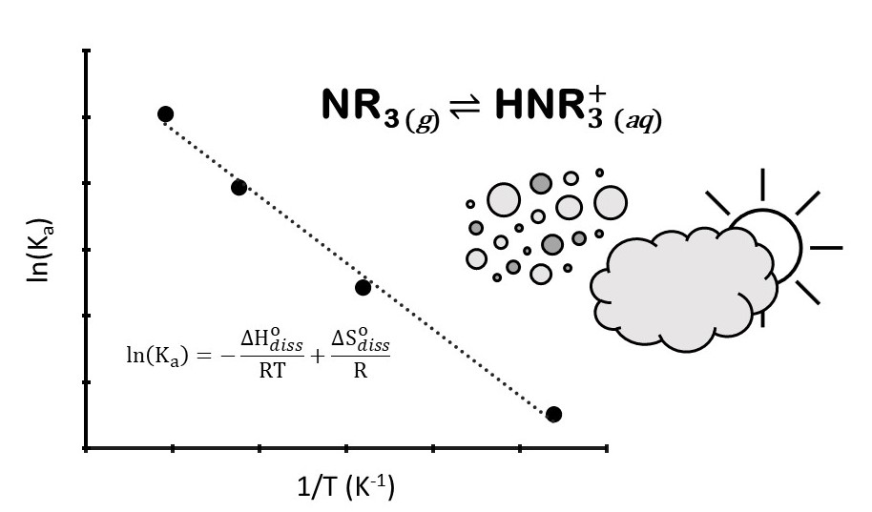

**Identifying and quantifying atmospheric sources of organic contaminants to the habitat of the St. Lawrence Estuary Belugas**

*Jenny Oh and Frank Wania*

Persistent organic contaminants, such as the polychlorinated biphenyls (PCBs), have been shown to bioaccumulate in the Saint Lawrence Estuary Belugas (SLEBs) and may be impacting their health. Atmospheric deposition is often the dominant source of organic contaminants to aquatic ecosystems and is likely also important in delivering PCBs to the SLEB habitat. We quantified concentrations of organic contaminants for the SLEBs in air, water and atmospheric deposition using networks of passive air and water samplers across Quebec, coupled with active air and deposition samplers in Tadoussac. The passive air sampling (PAS) network encompassed the St. Lawrence River valley between Montreal and Quebec City as well as the shores of the estuary up to Sept-Îles and Sainte-Anne-des-Monts. Air concentrations of PCBs were elevated at most sites along the Montreal-Quebec City corridor, consistent with the region's high population density and industrial history. Locally elevated levels also point to the existence of PCB sources to the atmosphere along the shores of the estuary (Sept-Îles) and in the Lac-Saint-Jean region (Alma). Conversely, the PAS network could exclude several electrical transformer stations as significant sources of PCBs to the atmosphere. The analysis of many PCB congeners allows us to employ multivariate statistical approaches to distinguish between PCB sources related to the use of technical PCB mixtures and those resulting from unintentionally produced PCBs. Combining our measurements with atmospheric dispersion and deposition calculations, driven by historical emission estimates, facilitates the estimation of the time-varying atmospheric input of PCBs to the habitat of the SLEBs.

**Benchmarking a portable sensor for early warning monitoring of water quality**

*Zhuoyuan Li and Hui Peng*

Microcystins (MCs) are toxic compounds produced by cyanobacteria during harmful algal blooms (HABs) in freshwater sources, which can pose significant health risks to humans including liver damage, respiratory paralysis, and mortality. HABs typically occur in summer and autumn due to environmental factors such as warm water, abundant sunshine, and nutrient availability. Human activities such as agriculture, urbanization, and industrialization have increased nutrient loads, including nitrogen and phosphorus, in freshwater systems, which can contribute to cyanobacterial dominance. Nitrate, an inorganic form of nitrogen, is commonly used as an indicator of cyanobacterial dominance due to its abundance and availability as a nitrogen source for cyanobacteria. The established method for measuring nitrate and MCs in surface waters is ion chromatography (IC) and mass spectrometry separately. There is a need for portable and on-site measurement methods.

In this study, a direct method using a prototype UV-VIS sensor system provided by our industrial partner AUG Inc. was employed to measure nitrate and humic acids levels in lake water samples by detecting full wavelength absorbance. The sensor results were cross-validated with laboratory testing using IC and High-Resolution Mass Spectrometry (HRMS). The findings showed that the UV-VIS sensor accurately measured nitrate levels but was not reliable for indirect measurement of MCs concentrations due to its low concentration. Ongoing research is trying to upgrade the UV-VIS sensor to achieve the direct measurement of MCs and other trace – level water contaminants.

